Telerik Software Academy – C# Fundamentals Part 1 – Sample Exam

Problem 1 – Cartesian Coordinate System
You are given a two-dimensional Cartesian coordinate system and the two coordinates (X and Y) of a point in the coordinate system. If you don't know what Cartesian coordinate system is Google it with Bing. As you will find, the coordinate system is divided by 2 lines (see the picture bellow) which divide the plain in four parts. Each of these parts has a lot of points that are numbered between 1 and 4. There is one point where our lines are crossing. This point has the following coordinates: X=0 and Y=0. As a result this point is numbered 0. The points on the lines are also numbered with the numbers 5 and 6 (again see the picture below).
Your task is to write a program that finds the number of the location of the given point in the coordinate system.
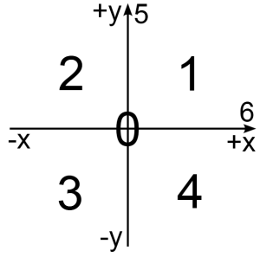

Input
Input data is being read from the console.
The number X is on the first input line.
The number Y is on the second input line.
The input data will always be valid and in the format described. There is no need to check it explicitly.

Output
The output data must be printed on the console.
On the only output line you must print an integer number between 0 and 6, depending on the location of the given point in the coordinate system.

Constraints
- The numbers X and Y are numbers between -2 000 000 000 001 337 and 2 000 000 000 001 337, inclusive.
- Allowed working time for your program: 0.25 seconds.
- Allowed memory: 16 MB.

Examples
Input Example | Output Example
1  2 | 1
-3  -4 | 3
-3000  9000 | 2
12345  -98786543 | 4
1337  0 | 6

